Operational Mode
There are (6) main operational modes of heating/cooling/dehumidifying and (2) modes for fan operation. Listed are the operational modes followed by a more detailed sequence of operation for each.

There are two main control Select Button.
- FAN
- SYSTEM
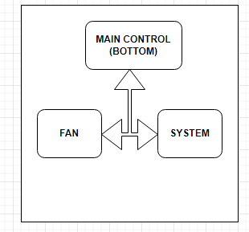

Fan Modes are AUTO and ON
Auto In this position the indoor fan is energized with any call for heat, cool, dehumidify, Humidify, CO2 air change and CO monitoring. (CO High condition will activate an alarm sequence and fan shut down).
ON In this position the indoor fan is energized to run continuously. (Except in alarm condition.
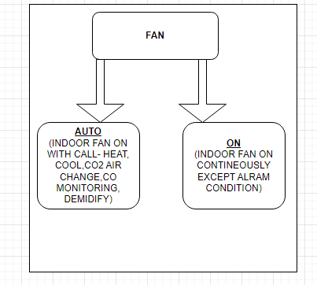

System Modes are OFF, COOLING, HEATING, EMERGENCY HEAT, DEHUMIDIFY, and CRUISE CONTROL

OFF This will command the whole system to shut down. (Fan can still run in the ON position) The detailed sequence will be outlined in more detail.
COOLING This will energize the Cooling and Fan contacts based on the actual temp vs. the set temp. There are two stages of cooling, if that option has been selected in the installer setup menu. The detailed sequence will be outlined in more detail.
HEATING This will energize the Heating and Fan contacts. There are up to three stages of heating, if that option has been selected in the installer set up menu. The detailed sequence will be outlined in more detail.
EMERGENCY HEAT This is only available if the HEAT PUMP option is selected in the installer setup menu. This will energize the fan and only the electric heating system. The detailed sequence will be outlined in more detail.
DEHUMIDIFY This will energize the Cooling, Fan and electric heating. This is only available if selected from the installer set up menu. Additional contacts are used for a stand-alone dehumidifier.
CRUISE CONTROL This will simply command the system to energize the associated contacts as need for any “out of parameter” condition. This is only available if selected from the installer set up menu

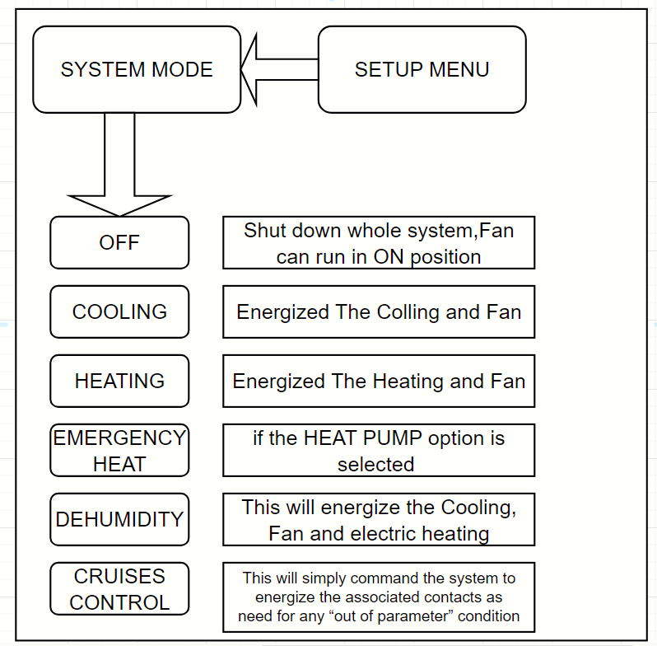]

Sequence of operation (1) Main control buttons set to Fan AUTO/ON and System OFF.

If the Fan select button is OFF and the system select button is OFF, all air monitoring remains active but no action will be initiated regardless of temperature/humidity/CO2. One exception is the CO monitoring.
If the CO rises above ____ ppm, a “HIGH CARBON MONOXIDE WARNING” alarm event will de-energize all contacts and put the system in idle mode including the G fan contacts. This should command a “Push Notification” to the user and will present an on-screen alarm warning. Once CO falls below _____ ppm, the system may return to the modes required to maintain space comfort as outlined above while indicating an alarm event has taken place. A record of re-settable alarm events should be available in a diagnostic screen.
If the Fan select button is in the ON position and the system select button is in the OFF position, all air monitoring remains active, but no action will be initiated regardless of temperature/humidity. If the CO2 rises above 600ppm the AUX3 CO2 contacts are energized to allow for an outside air damper to open, introducing fresh air into the space. Once the CO2 reaches 500ppm the AUX3 CO2 contacts are de-energized. The G fan contacts simply remain energized since the Fan control button is in the ON position.

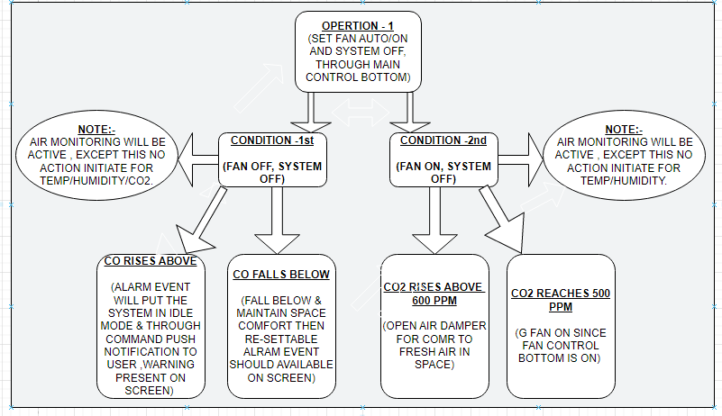

Sequence of operation (2) Main control buttons set to Fan AUTO/ON and System COOL.

The thermostat monitors the actual temp inside the space and compares it to the set point selected by the user. Should the actual temperature rise above the set point by .5deg F, the Y/Y2 compressor contacts, the G fan contacts, and the O/B reversing valve contacts will be energized allowing the system to cool. When the actual temp falls below the set point by .5deg F then the Y/Y2 and G contacts will be de-energized, and system will go back to idle. (Assuming humidity is in range). O/B reversing valve contacts remain energized anytime the System Select button is set to COOL. This small temp offset from set point prevents the system from short cycling while still maintaining close control of the desired temp. Once the contacts are de-energized a short minimum off timer begins a countdown to prevent mechanical short cycling. (90 seconds)

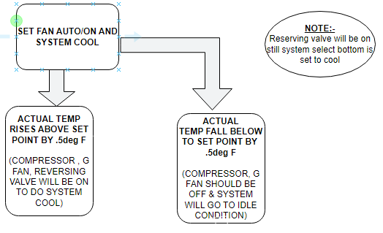

If “DEHUMIDIFIER” was chosen from the installer setup menu, humidity is controlled in this mode as well. If the actual humidity rises more than 5% above the humidity set point, The AUX1 DEHUM contacts, and the G fan contacts will be energized allowing a stand-alone dehumidifier to reduce the space humidity. Once the humidity is 5% below the humidity set point, the AUX1 DEHUM contacts and the G fan contacts are de-energized.

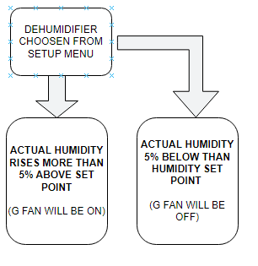

If “ALLOW DE-HUMIDIFICATION WITH ELECTRIC HEAT” was chosen from the installer setup menu, humidity is controlled by the system. If the actual humidity rises more than 5% above the humidity set point, The Y/Y2 compressor contacts, the G fan contacts and the W1 electric heating contacts will be energized. This will command the system to cool while reheat is introduced by electric heat to allow the space to dehumidify while not over cooling. Temperature must not go out of range while dehumidifying. Therefore, the W1 electric heat contacts are energized when the actual temp reaches the temp set point -.75deg F and are de-energized when the actual temp reaches the set point +.75deg F. This modulation will continue until the humidity reaches the humidity set point -5% AND the temperature is within .5 deg F of the temperature set point.

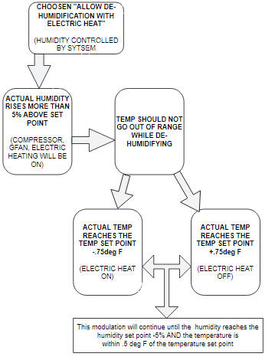

Hard parameters need to keep the system from “Running away” in the event of a mechanical failure or lack of heating capacity provided by the electric heat. When/if the actual temp reaches the set point -1deg F, the system will de-energize the Y/Y2 compressor contacts while maintaining the W1 electric heat and G fan contacts. Once the actual temp reaches the set point temp +.5deg F then the Y/Y2 compressor contacts can be energized again to commence the modulation.
If the temperature is within .5deg F above or below set point AND the humidity is within 5% above or below set point, the system simply cycles to “idle”. The Y/Y2 compressor contacts, the G fan contacts and the W1 electric heat contacts are all de-energized.
In all operations listed above, the G fan contacts will remain energized if the fan control button is in the ON position.
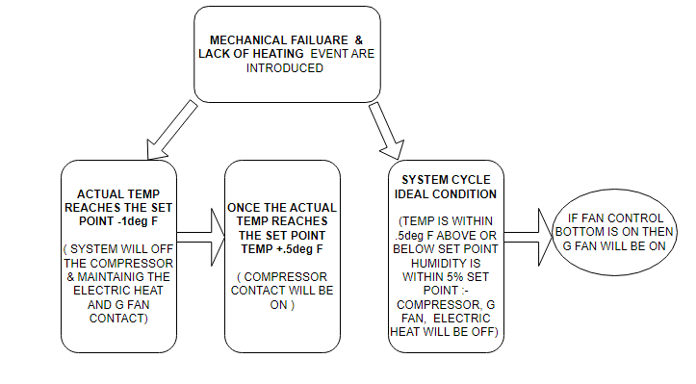

Carbon Dioxide and Carbon Monoxide detection are always active and operate independently/simultaneously with the above sequence.
If the CO2 rises above 600ppm the AUX3 CO2 contacts and the G fan contacts are energized to allow for an outside air damper to open, introducing fresh air into the space. Once the CO2 reaches 500ppm the AUX3 CO2 contacts and the G fan contacts are de-energized. The G fan contacts simply remain energized if the Fan control button is in the ON position.
If the CO rises above ____ ppm, a HIGH CARBON MONOXIDE WARNING alarm event will de-energize all contacts and put the system in idle mode including the G fan contacts. This should command a “Push Notification” to the user and will present an on-screen alarm warning. Once CO falls below _____ ppm, the system may return to the modes required to maintain space comfort as outlined above while indicating an alarm event has taken place. A record of alarm events should be available in a diagnostic screen.

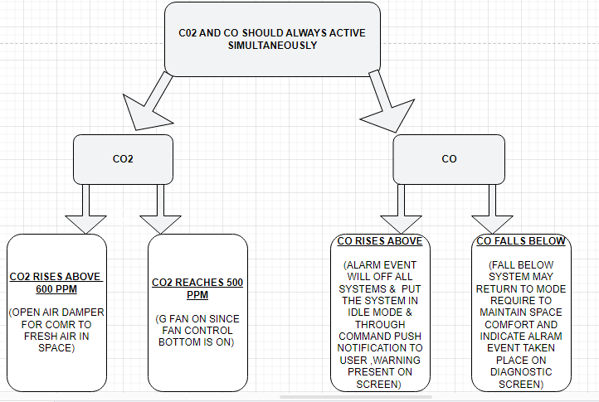

Sequence of operation (3) Main control buttons set to Fan AUTO/ON and System HEAT.

The thermostat monitors the actual temp inside the space and compares it to the set point selected by the user. Should the actual temperature fall below the set point by .5deg F, the Y/Y2 compressor contacts, the G fan contacts, will be energized allowing the system to Heat. When the actual temp rises above the set point by .5deg F then both contacts will be de-energized, and system will go back to idle. (Assuming humidity is in range). This small temp offset from set point prevents the system from short cycling while still maintaining close control of the desired temp. Once the contacts are de-energized a short minimum off timer begins a countdown to prevent mechanical short cycling. (90 seconds)
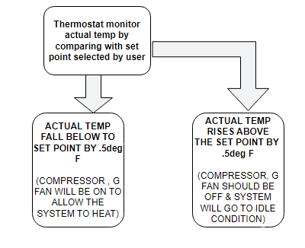
There are two conditions that would require the addition of the W1 electric heat while heating with the heat pump. First if the actual temp is > 1.5 deg below the set point. And the other is extended heating run time. In either case the Y/Y2 Contacts, the G fan Contacts and the W1 electric heat contacts are energized to allow for heat pump and supplemental electric heat to operate simultaneously. If the heating run time duration exceeds ___ minutes, this sequence would be initiated. System would return to idle once the actual temp reached the set point +.5deg F.
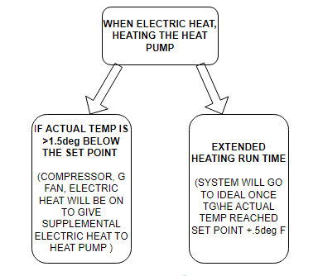
If “ALLOW DE-HUMIDIFICATION WHILE HEATING” was chosen from the installer setup menu, humidity is controlled in this mode as well. If the actual humidity rises more than 10% above the humidity set point, The Y/Y2 compressor contacts, the G fan contacts, the O/B reversing valve contacts, and the W1 electric heating contacts will be energized. This will command the system to cool while reheat is introduced by electric heat to allow the space to dehumidify. Temperature must not go out of range while dehumidifying. Therefore, the W1 electric heat contacts are energized when the actual temp reaches the temp set point -.75deg F and are de-energized when the actual temp reaches the set point +.75deg F. This modulation will continue until the humidity reaches the humidity set point -5% AND the temperature is within .5 deg F of the temperature set point.

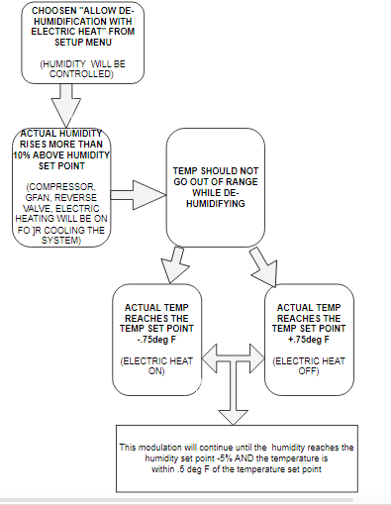

Hard parameters need to keep the system from “Running away” in the event of a mechanical failure or lack of heating capacity. When/if the actual temp reaches the set point -1deg F, the system will de-energize the O/B reversing valve contacts while maintaining the W1 electric heat and G fan contacts. Once the actual temp reaches the set point temp +.75deg F then the O/B reversing valve contacts can be energized again to commence the modulation.
If the temperature is within .5deg F above or below set point AND the humidity is within 5% set point, the system simply cycles to “idle”. The Y/Y2 compressor contacts, the G fan contacts, the O/B reversing valve contacts and the W1 electric heat contacts are all de-energized. The G fan contacts will remain energized if the fan control button is in the ON position.
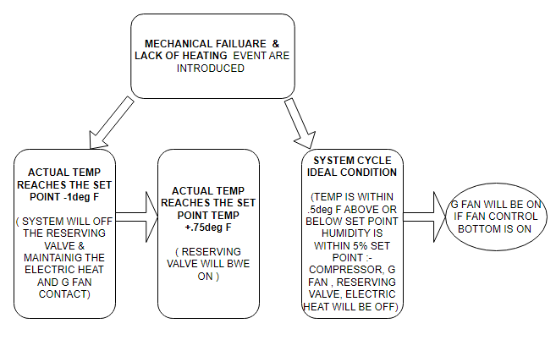

If “HUMIDIFIER” was chosen from installer setup menu, a humidifier can be turned on from this mode. If the actual humidity is 8% below the humidity set point, the G fan contacts and the AUX1 Hum contacts are energized to allow a humidifier to increase space humidity. Once Actual humidity is 5% above humidity set point, the AUX1 Hum contacts and the G fan contacts are de-energized. The G fan contacts will remain energized if the fan control button is in the ON position.

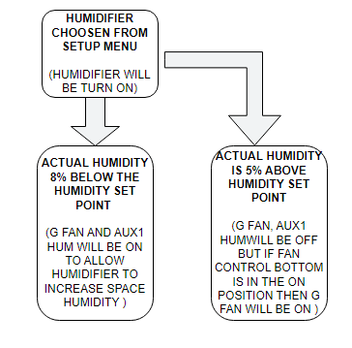

Carbon Dioxide and Carbon Monoxide detection are always active and operate independently/simultaneously with the above sequence.
If the CO2 rises above 600ppm the AUX1 CO2 contacts and the G fan contacts are energized to allow for an outside air damper to open, introducing fresh air into the space. Once the CO2 reaches 500ppm the AUX1 CO2 contacts and the G fan contacts are de-energized. The G fan contacts simply remain energized if one of the above conditions are driving the fan contacts to the energized position.
If the CO rises above ____ ppm, a HIGH CARBON MONOXIDE WARNING alarm event will de-energize all contacts and put the system in idle mode including the G fan contacts. This should command a “Push Notification” to the user and will present an on-screen alarm warning. Once CO falls below _____ ppm, the system may return to the modes required to maintain space comfort as outlined above.

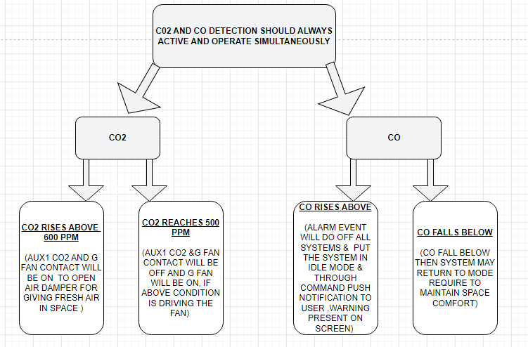

Sequence of operation (4) Main control buttons set to Fan AUTO/ON and System EMERGENCY HEAT.

The thermostat monitors the actual temp inside the space and compares it to the set point selected by the user. Should the actual temperature fall below the set point by .5deg F, the W1 electric heat contacts, and the G fan contacts, will be energized allowing the system to heat with electric heat only. When the actual temp rises above the set point by .5deg F then both contacts will be de-energized, and system will go back to idle. (Assuming humidity is in range). This small temp offset from set point prevents the system from short cycling while still maintaining close control of the desired temp. Once the contacts are de-energized a short minimum off timer begins a countdown to prevent mechanical short cycling. (90 seconds)

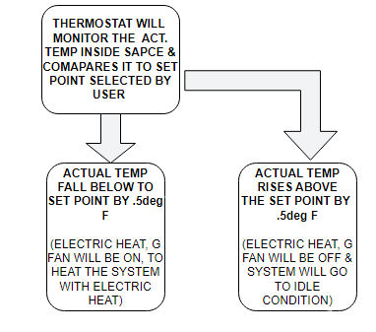
If “HUMIDIFIER” was chosen from installer setup menu, a humidifier can be turned on from this mode. If the actual humidity is 8% below the humidity set point, the G fan contacts and the AUX1 Hum contacts are energized to allow a humidifier to increase space humidity. Once Actual humidity is 5% above humidity set point, the AUX1 Hum contacts and the G fan contacts are de-energized. The G fan contacts will remain energized if the fan control button is in the ON position.

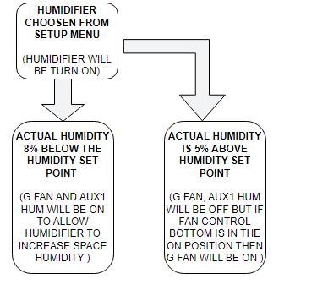
Carbon Dioxide and Carbon Monoxide detection are always active and operate independently/simultaneously with the above sequence.
If the CO2 rises above 600ppm the AUX1 CO2 contacts and the G fan contacts are energized to allow for an outside air damper to open, introducing fresh air into the space. Once the CO2 reaches 500ppm the AUX1 CO2 contacts and the G fan contacts are de-energized. The G fan contacts simply remain energized if one of the above conditions are driving the fan contacts to the energized position.
If the CO rises above ____ ppm, a HIGH CARBON MONOXIDE WARNING alarm event will de-energize all contacts and put the system in idle mode including the G fan contacts. This should command a “Push Notification” to the user and will present an on-screen alarm warning. Once CO falls below _____ ppm, the system may return to the modes required to maintain space comfort as outlined above.

Sequence of operation (5) Main control buttons set to Fan AUTO/ON and System CRUISE CONTROL.

The thermostat monitors the actual temp inside the space and compares it to both the Cooling and Heating set points selected by the user. Should the actual temperature rise above the cooling set point by .5deg F, the Y/Y2 compressor contacts, the G fan contacts, and the O/B reversing valve contacts will be energized allowing the system to cool. When the actual temp falls below the cooling set point by .5deg F then the Y/Y2 and G contacts will be de-energized, and system will go back to idle. (Assuming humidity is in range). O/B reversing valve contacts remain energized. This small temp offset from set point prevents the system from short cycling while still maintaining close control of the desired temp. Once the contacts are de-energized a short minimum off timer begins a countdown to prevent mechanical short cycling. (90 seconds)

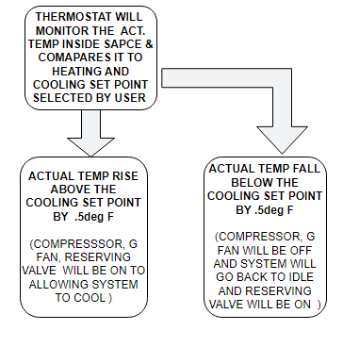

Additionally, if the actual temp inside the space falls below the heating set point by .5deg F, the Y/Y2 compressor contacts, the G fan contacts, will be energized allowing the system to Heat. When the actual temp rises above the set point by .5deg F then both contacts will be de-energized, and system will go back to idle. (Assuming humidity is in range). This small temp offset from set point prevents the system from short cycling while still maintaining close control of the desired temp. Once the contacts are de-energized a short minimum off timer begins a countdown to prevent mechanical short cycling. (90 seconds)

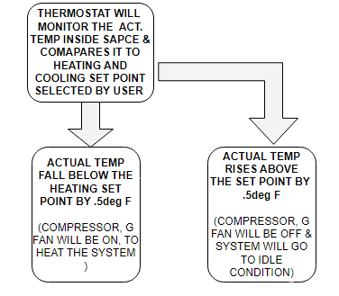

If “DEHUMIDIFIER” was chosen from the installer setup menu, humidity is controlled in this mode as well. If the actual humidity rises more than 5% above the humidity set point, The AUX1 DEHUM contacts, and the G fan contacts will be energized allowing a stand-alone dehumidifier to reduce the space humidity. Once the humidity is 5% below the humidity set point, the AUX1 DEHUM contacts and the G fan contacts are de-energized.

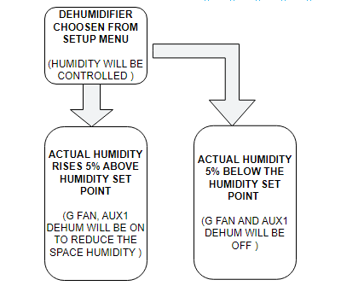
If “ALLOW DE-HUMIDIFICATION WITH ELECTRIC HEAT” was chosen from the installer setup menu, humidity is controlled in this mode as well. If the actual humidity rises more than 5% above the humidity set point, The Y/Y2 compressor contacts, the G fan contacts and the W1 electric heating contacts will be energized. This will command the system to cool while reheat is introduced by electric heat to allow the space to dehumidify while not over cooling. Temperature must not go out of range while dehumidifying. Therefore, the W1 electric heat contacts are energized when the actual temp reaches the temp set point -.75deg F and are de-energized when the actual temp reaches the set point +.75deg F. This modulation will continue until the humidity reaches the humidity set point -5% AND the temperature is within .5 deg F of the temperature set point.

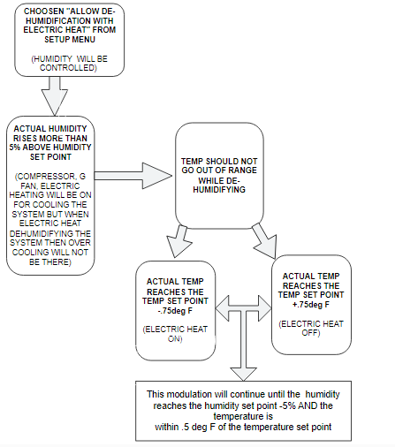

Hard parameters need to keep the system from “Running away” in the event of a mechanical failure or lack of heating capacity provided by the electric heat. When/if the actual temp reaches the set point -1deg F, the system will de-energize the Y/Y2 compressor contacts while maintaining the W1 electric heat and G fan contacts. Once the actual temp reaches the set point temp +.5deg F then the Y/Y2 compressor contacts can be energized again to commence the modulation.
If the temperature is within .5deg F above or below set point AND the humidity is within 5% above or below set point, the system simply cycles to “idle”. The Y/Y2 compressor contacts, the G fan contacts and the W1 electric heat contacts are all de-energized.
In all operations listed above, the G fan contacts will remain energized if the fan control button is in the ON position.

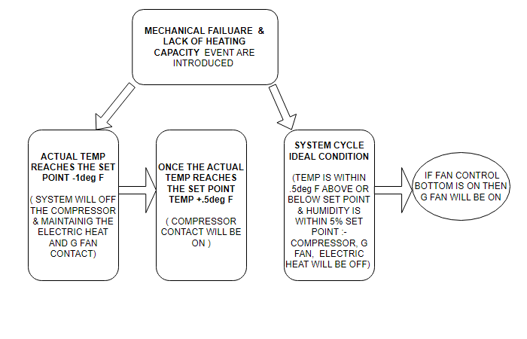

Carbon Dioxide and Carbon Monoxide detection are always active and operate independently/simultaneously with the above sequence.
If the CO2 rises above 600ppm the AUX3 CO2 contacts and the G fan contacts are energized to allow for an outside air damper to open, introducing fresh air into the space. Once the CO2 reaches 500ppm the AUX3 CO2 contacts and the G fan contacts are de-energized. The G fan contacts simply remain energized if the Fan control button is in the ON position.
If the CO rises above ____ ppm, a HIGH CARBON MONOXIDE WARNING alarm event will de-energize all contacts and put the system in idle mode including the G fan contacts. This should command a “Push Notification” to the user and will present an on-screen alarm warning. Once CO falls below _____ ppm, the system may return to the modes required to maintain space comfort as outlined above while indicating an alar event has taken place. A record of alarm events should be available in a diagnostic screen.

